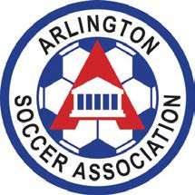

Parent Code of Conduct
Parents have the biggest impact on a player’s enjoyment of the game. To help foster a positive experience in youth sports for your child, as well as the others on their team and those they play against, please adhere to the following guidelines:

- I will foster good sportsmanship by demonstrating positive support for all players, coaches, and officials at every game, practice, or other sports events.
- I will place the emotional and physical well-being of my child before a personal desire to win.
- I will support coaches and officials working with my child, to encourage a positive and enjoyable experience for all. I recognize that the coaches are volunteers, who are donating their time to help my child play a sport.
- I will remember that the game is for the kids - - not the adults. I understand that the three top reasons kids play sports are: a) to have fun, b) to make new friends, and c) to learn new skills
- I will advocate a sports environment for my child that is free of drugs, tobacco, alcohol, abusive language and will refrain from their use during youth sports events.
- I will encourage my child to play by the rules, respect the rights of other players, coaches, fans and officials, and follow the ASA Player Code of Conduct.

