TEAM MANAGER NOTEBOOK

Must Have Items in your Team Manager Notebook
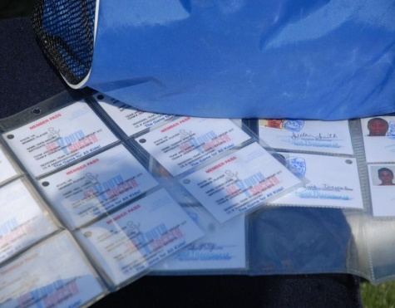
- Player Passes (Lamination is recommended and required for State Cup and CCL League games) Not having player passes at the games can result in a forfeit for your team.
- Coach/Official Passes (anyone on the team sideline must have their official pass)
- Stamped, Approved VYSA Roster (and State Cup Roster if playing State Cup)
- Player Medical Release Forms
- Game Card/Referee Card **
- Roster Labels or Game Day Roster**
- Pen
- League Rules
- Contact Information for Opponent**
- Team Phone/Contact List (all these numbers should also be programmed into your cell phone)
- Chart to keep track of player cards/points**
- Phone number or web address to report scores upon completion of game**
- Phone number of ASA Rover (for home games)
- Phone number of your ASA Club league representative (if issues arise)

** Items vary by league. Consult your league rules for specifics

