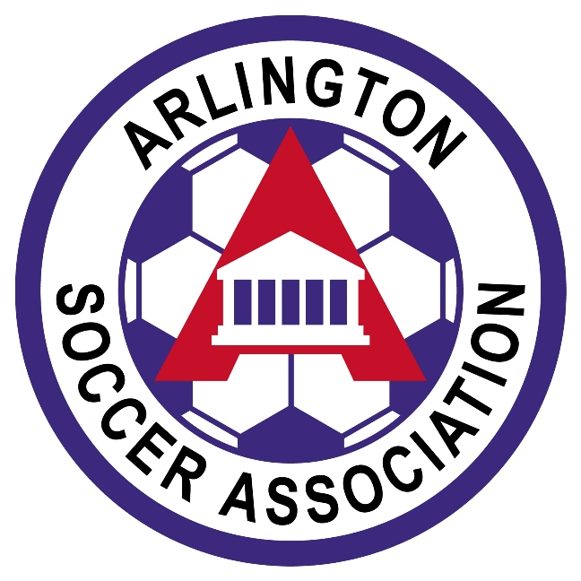(Checklist is for Teams to KEEP – do not turn in)

Beginning of Year Checklist for Players on Travel Teams
Team Name _____________________________ Boys/Girls Age: _______U

 |  |  |  |  | Player Pass
Jersey # | Player Name | Submitted info for TeamSnap  (address, cell and home #’s, email address, etc)  Notate each parent’s selected volunteer job on contact list (i.e. registrar, treasurer, etc) | Completed Medical Release  Does NOT need to be notarized  Kept in Team Manager  Notebook  DO NOT  Turn In | Signed League Code of Conduct  NCSL Teams keep in team files; ODSL teams turn in when player is rostered.  CCL teams– no code of conduct required | Proof of Birth  If rostered last year, on an ASA travel team, proof of birth docs are already stored in the VYSA database.  Everybody else needs to supply proof of birth date docs. | Photo for Player pass  All players must submit a Current, full-face, photo.  Min.size  1” x 1”;  max. size 1.5” x 1.5”.  .jpg file REQUIRED  Photos are good for only two years | Uniform  Player has a uniform kit or ordered a uniform kit

Team TO DO: (9U) teams need to set up a Team Account by July 1st. Contact ASA Finance Manager, Diane Oden, dianeoden@arlingtonsoccer.com.

