|  |  |
| --- | --- |
| ASA_Logo_smalljpg | **Guide to Travel Soccer Tournaments**  **for Travel Team Coordinators**  Arlington Soccer Association (ASA)  Last updated March 2018 |

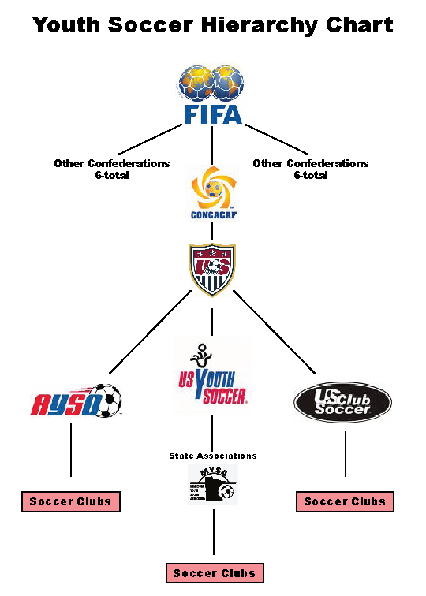Arlington Soccer Association is a member of the Virginia Youth Soccer Association (VYSA). Membership in VYSA also brings with it membership in the United States Youth Soccer Association (US Youth Soccer) and US Youth Soccer’s Region I (Virginia to Maine).  US Youth Soccer develops and promotes youth soccer in 50 states and the District of Columbia.  It currently has over 3,000,000 youth soccer players, with Region I having over 1,000,000 of those players.  US Youth Soccer is a National Association member of the United States Soccer Federation (USSF). USSF is the governing body of soccer in the United States, as recognized by the United States Olympic Committee and the International Olympic Committee, that develops soccer at all levels, youth and adult, amateur and professional.

ASA travel teams are registered for league and tournament play as ***US Youth Soccer*** teams. Please note your player’s passes indicate they are only valid for ***US Youth Soccer*** Events.

**SELECTING TOURNAMENTS**

A Team Activity Plan lists all the tournaments and other events (i.e. State Cup, Team Camps, Showcases, etc.) the team will be participating in during the coming year. Teams are responsible for applying to these required events. Any additional events must be approved by the team’s Age Group Director (AGD) BEFORE the team applies for the event. Be sure and note the deadlines for tournament applications, some tournaments have application deadline dates months in advance of the tournament.

**APPLYING FOR TOURNAMENTS**

**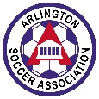**Applying for tournaments is now an on-line process for almost all tournaments. Tournament websites can be found by performing an internet search using the name of the tournament or the name of the sponsoring soccer club. US Youth Soccer sanctioned tournaments in Virginia are listed [HERE.](http://www.vysa.com/tournaments/index_E.html) The US Youth Soccer National Tournament database is listed [HERE](https://www.usyouthsoccer.org/tournaments/).

Most of the information required on a tournament application can be pulled directly from your team’s roster (which your team manager should have) or from your team’s tournament history (your team manager or previous team tournament coordinator should have a copy of this document).

[](http://sites.google.com/site/shswomensvarsitysoccer/soccer-links-2/gotsoccerrankings/gotsoccer.png?attredirects=0)[](http://www.google.com/imgres?imgurl=https://ssl.hammersoccer.com/eNewsletter/Photos/GotSoccer.JPG&imgrefurl=http://www.indyfusionsoccer.com/newsarticle.php?newsid=45&usg=__cSCMHwc7axUDbzk4PPX3vdQ4X1o=&h=180&w=720&sz=19&hl=en&start=9&zoom=1&tbnid=Fv0IgpFdW9LV8M:&tbnh=35&tbnw=140&ei=6omqTZWHDOqY0QHk-8X5CA&prev=/images?q=got+soccer&um=1&hl=en&sa=N&rlz=1R2ADSA_enUS378&biw=1896&bih=808&tbm=isch&um=1&itbs=1)***A note about GotSoccer:***Many tournaments use GotSoccer as a management tool. Thus, the tournament application process utilizes information that is gathered and stored in the GotSoccer system. This include Gotsoccer points.  It is smart to keep your team’s GotSoccer account ([www.soccerscheduler.com](http://www.soccerscheduler.com/)) current and to input your team’s roster and play history onto the site. Doing so will make applying to most tournaments relatively easy.

All teams except our new 9U teams have existing Got Soccer accounts.  Returning travel teams should log into their account after teams are formed in June and update their roster/coach/team manager.  The past tournament coordinator or team manager should have the Got Soccer log in information.  If not, ASA Staff can get this information for you**.  PLEASE DO NOT CREATE A NEW ACCOUNT.**  Only 9U teams should create new team accounts.

When completing a tournament application pay close attention to how you list your team name. Many clubs have similar acronyms thus our state association (VSYA) and local leagues have developed distinct acronyms to identify our travel teams.

* VYSA, NCSL and ODSL refer to Arlington Soccer Association as “ARL”.
* CCL refers to Arlington Soccer Association as “Arlington”

Thus, you will see your team posted on State cup or league game schedules as ARL 2005G Red or ARLINGTON 20005G Red.

To be consistent when listing team names on documents such as tournament applications & state cup registration, teams are required to use the following naming convention:

Club name, birth year, gender, and team color

An example is “Arlington Soccer 2004B White”

If applying for an out of state/area tournament or showcase you might even add “(VA)” in your team name to differentiate your team from the Arlington, Texas travel teams. Example: Arlington Soccer (VA) 2004B White

*As an FYI: ASA is NCSL’s acronym for Alexandria Soccer Association and MYSA’s acronym for Arundel Soccer Association is ASA*.

**TOURNAMENT PAYMENTS**

A team treasurer, team tournament coordinator or the team manager can complete and submit check requests/reimbursements forms to pay tournament application fees.

There are several ways to pay for a tournament:

1. Most tournaments require application payment via credit card. Team enters tournament and the team submits a reimbursement form to pay back the person, from the team account, whose credit card was used.
2. Team enters tournament. Then team submits their request for a tournament check using the Check Request form (be sure to include a copy of your tournament application submission as back up).
3. Since many of our ASA Travel teams attend the same tournaments the club has asked several tournaments if they would be willing to invoice ASA and ASA writes one application check to cover all teams’ application fees. Once the club receives the tournament invoice the club transfers money out of the team accounts and writes one check to cover all the ASA teams attending that tournament. Not all tournaments will invoice the club, even if our club is sending a large number of teams to that tournament. The list of tournaments who will invoice ASA is posted on the **Team Management** page of the club website under the Tournament Coordinator and Treasurer headings. **Please consult this list to see if the tournament you are applying to will invoice the club. Please note that tournaments do not invoice until after the tournament application deadline and tournament application fees will not be paid until after the invoice is received.**

To submit a request for reimbursement:

**Expense Reimbursement Form** - Complete Expense Reimbursement Form and staple appropriate documentation (copy of credit card statement, copy of submitted tournament application etc.) to the form. Reimbursements **MUST** have all attached documentation in order to be processed. Expense Reimbursement requests can be scanned and emailed, mailed (**EXPENSES@ARLINGTONSOCCER.COM**) or dropped off at the ASA office. Please allow seven (7) to ten (10) days for processing.

To submit a check request:

**Check Request Form** – Complete Check Request Form and staple back-up material (invoice or event registration form) to the Check Request form. Check requests can be scanned and emailed, mailed or dropped off at the ASA office. Please allow seven (7) days for processing. If check request is urgent, please be sure to indicate this on the check request form.

Some tournaments charge teams a performance bond as part of their tournament application fee. This “bond” is typically added to the tournament fee for High School aged teams to ensure they will show up and participate in the tournament. The bond (usually several hundred dollars) is paid when applying for the tournament. If the team shows up and plays in the tournament as promised the bond is returned (or bond check is torn up).

**TRAVEL AUTHORIZATION**

Once you have applied for a tournament check to see if you need to complete and submit Authorization to Travel paperwork.

***Travel Authorization -* The state of Virginia is a member of US Youth Soccer Region One.** Other members of Region one are Connecticut, Delaware, Eastern New York, Eastern Pennsylvania, Maine, Maryland, Massachusetts, New Hampshire, New Jersey, New York State West, Pennsylvania West, Rhode Island, Vermont and West Virginia

***Tournaments held within the Region One states:***  *ASA* teams may enter tournaments within the Region One states without receiving permission to travel because our insurance already covers teams whenever they play within the Region One states. There are exceptions to this general rule – so please confirm with the specific tournament!

***Tournaments held outside the Region One states:***  Tournaments held outside of the Region One Areausually require a Travel Authorization.Any time an ASA travel team enters a tournament outside of Region One and within the US, Canada or Mexico, it must obtain a Travel Authorization (this replaces the old Permission to Travel authorization form). This is a mechanism to ensure that teams are covered by insurance when traveling outside of the Region One area.

Travel authorization is approved directly by VYSA. To obtain a Travel Authorization, go on line to the VYSA web site under Registration. Completing the form is quick and easy. Please note that the authorization will be emailed directly to the email address you provide. Make at least one copy of the form – one for your team and one to turn in at tournament registration, if required.

***Tournaments outside of North America:*** If your team wants to participate in a foreign tournament, contact ASA for permission and instructions.

**TOURNAMENT REGISTRATION**

All tournaments will require teams to register (this is different than applying). Most tournaments have moved to online tournament registration a week to 10 days prior to the tournament. Tournament registration information or “Check-in” information can be found on the tournament website. All tournaments will require at a minimum 1) a copy of the team’s VYSA League/Tournament approved, stamped roster 2) an approved player card for each player on the tournament roster and 3) a copy of the medical release for each player.  If you are also registering a player who is not on your roster (a so-called “guest” player), then you will need that guest player’s card and medical waiver as well as a guest player form (see further information below). You can coordinate with your team manager who will have a copy of the roster and player passes in their team manager notebook, along with a copy of every player’s medical release.

**Please be sure and work closely with your coach, team manager and registrar so everyone is aware of tournament registration deadlines. Once the on-line tournament registration date has passed many tournaments will not allow teams to alter their rosters. Thus, any player being added/transferred to your team’s roster needs to be taken care of and approved by VYSA the week prior to the tournament registration deadline. Please re-read this paragraph as teams that don’t communicate the deadline dates to their coach and manager find themselves stressing days before a tournament deadline – trying to make roster changes which may or may not be able to be approved prior to the deadline.**

**GUEST PLAYERS**

***Adding players to a tournament roster (Guest Players):*** ASA travel teams may invite additional players to attend tournaments with their team (they are called Guest Players). Most tournaments limit the number of guest players who may be added to the roster for tournament. Please consult rules for each tournament to determine all requirements for adding a guest player to your roster.

The correct procedure is for the borrowing coach to contact the player’s coach of record (before contacting the player) to obtain permission to invite the player to come to the tournament and to arrange to borrow the player’s player pass. Once permission is granted the player will need to secure their player pass and medical release form from their current team.

Some tournaments require a guest player form be completed. The guest player form can be found on the VYSA website.

**Recreational Player Pass** - Non-carded ASA house recreational players may sometimes guest play in travel tournaments. Check your tournament rules to ensure guest players and rec (vs Travel) passes are allowed. To obtain a rec pass for an ASA rec player:

Contact **Soraya Strobach, ASA Rec** Registrar, [registrar@arlingtonsoccer.com](mailto:registrar@arlingtonsoccer.com), to set up a time to process and pick up the rec pass. Soraya will provide the Rec registration link for the player to register. **Please select the pay by check option when registering**. The Rec pass costs $25.

The player’s parents should bring the following to the ASA Office (5210 Wilson Blvd in Arlington) when picking up a rec player pass:

* $25 payment (cash or check)
* Proof of age to prove player is age eligible to guest with the travel team. Virginia Youth Soccer Association (VYSA) accepts the following as verification of birth date.
  + Birth Certificate
  + Military ID
  + Board of Health Records with raised seal
  + Passport (current or expired)
  + Alien Resident Identification Card – Green Card
  + INS Certificate attesting to age
  + US Youth Soccer Pass from previous season (travel pass only, not a rec pass)
  + Current driver’s license, learner’s permit or “walker” ID

**Please allow up to a week to process a rec player pass.**

**INFORMATION TO SHARE WITH YOUR COACH**

Make two copies of the Tournament Rules and slip them in a page protector. Give one copy to the coach prior to the tournament, the other copy can be kept by the team manager in the manager notebook. As tournament rules vary highlight the number of guest players allowed, length of game, overtime rules, player substitution rules and tie-breaker rules. Then if question arise prior to or during the game you can consult the tournament rules.

**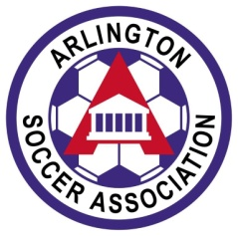PATCHES**

Travel Soccer patches are sometimes exchanged with opponents after each tournament game.  ASA patches can be purchased from ASA by emailing the ASA Registrar Soraya ([registrar@arlington.soccer.com](mailto:registrar@arlingtonsoccer.com)) at least one week before your tournament.  In your email, state how many patches you will need and the team's name, gender and age group.  Patches are packaged in batches of 50. Consider ordering enough patches to last your team through June.

If you have funds in your Team Account to pay for the patches, submit an ASA Check Request Form indicating payment from your team account. If you do not have funds in your team account, please write your personal check to ASA.

 You will receive an email when the patches are ready to be picked up at the ASA office (5210 Wilson Blvd Arlington, VA 22205).  There is usually someone in the office from 9am to 5pm Monday to Friday but please call ahead to confirm the office is open. The ASA office number is *703-527 -0157.*

**TOURNAMENTS AND HOTELS**

If you are traveling to a tournament where you will need to stay in a hotel, keep in mind that most tournaments require that you use their travel agency. This information will be clearly stated on the tournament website. Not staying at the required tournament hotels is often grounds for a forfeit and not being asked back to the tournament again.  Note also that some tournaments allow you to sign up for hotels **at the time** that you submit an application while others will not allow you to sign up for a hotel **until you are accepted.**The best travel experience will be had if you sign up for your hotel at the earliest option, selecting housing that meets your team’s requirements.

**Soccer Tournament Advice for Travel Teams**

Okay, so you’re a team manager or team tournament coordinator looking for youth soccer tournament advice because your first event is in a couple of months, and you’re overwhelmed by all the details you must take care of. Don’t worry. Planning your first trip to a soccer tournament can be pretty daunting. Here are ten tips that will help you keep your head straight and help your team have as enjoyable tournament experience as possible.

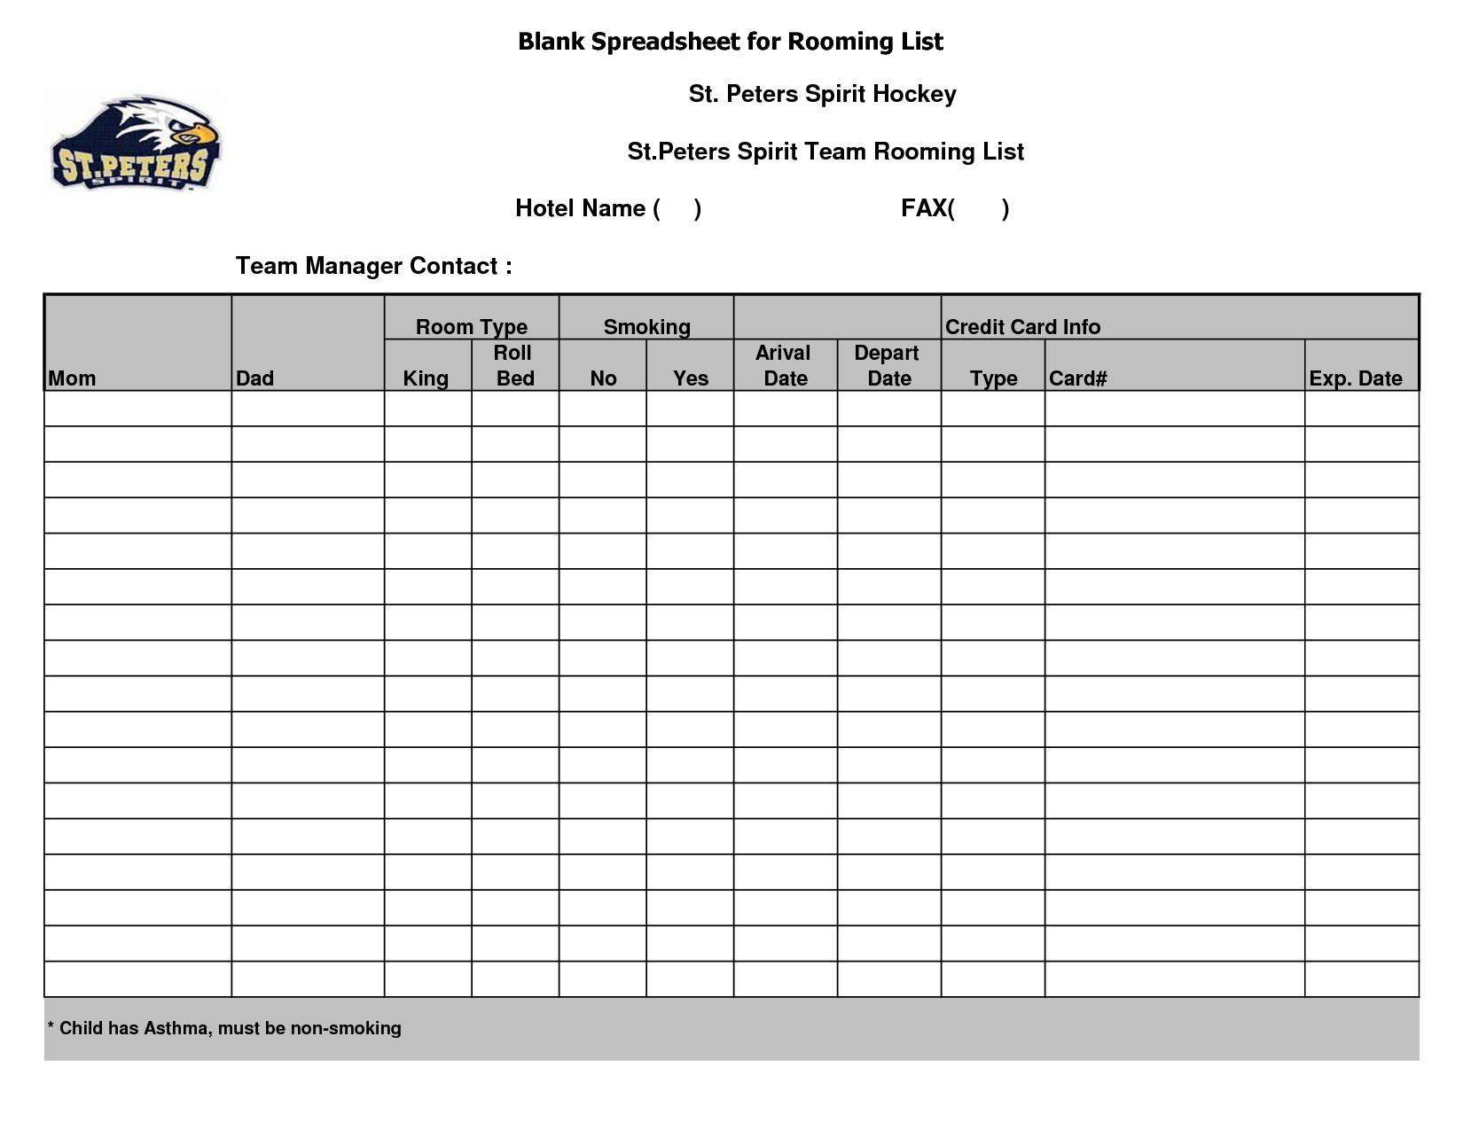1. Our first piece of youth soccer tournament advice is to complete all entry requirements and make sure you understand exactly what documentation you will be required to furnish at the tournament. Don't show up on the morning of the first game, only to discover that you missed the required tournament check-in.

2. Make reservations for hotel accommodations early. The tournament headquarters hotel is not always the best choice, since there is almost always a lot of commotion at the headquarters. All of your players should stay at the same hotel, which is why you need to make your reservations early.

3. Make sure to travel with signed Medical Consent forms.

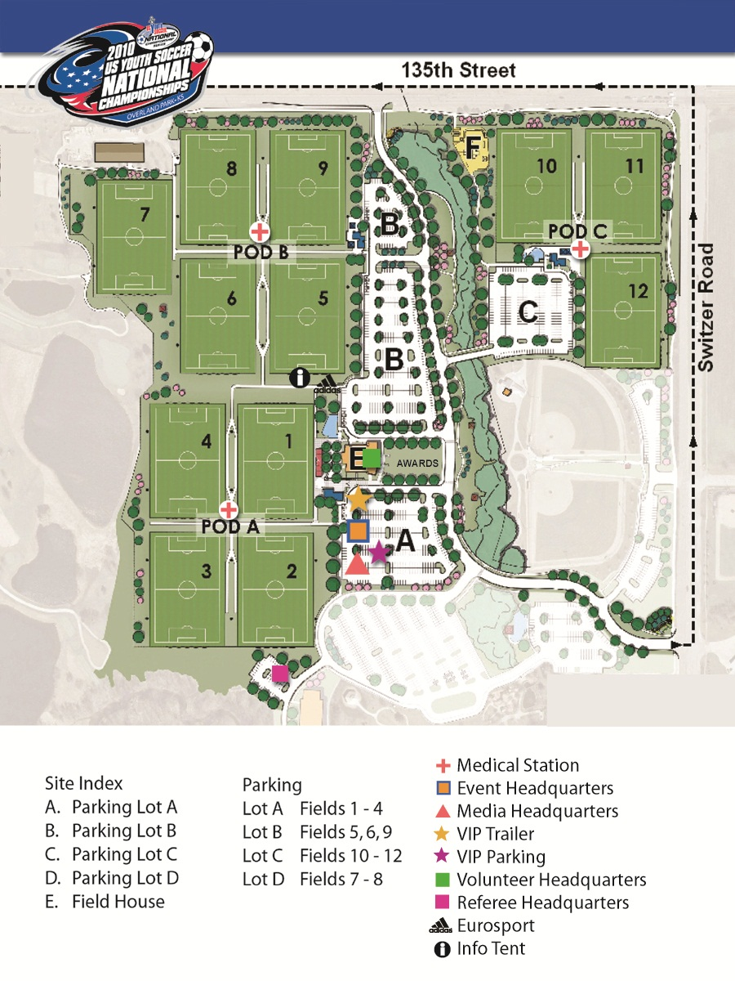4. Make sure everyone has maps and directions to ALL fields. And make sure that you have the cell phone numbers of all parents and drivers. In this age of GPS systems, it’s easy to get complacent about field directions, but fields aren’t like office buildings. Unless they’re part of a school or college, they often don’t have logical street addresses. A well-run tournament will provide directions to all field locations.

5. Plan to take the following equipment at a minimum with you to every game, a first aid kit, extra uniform, sun block, bug spray, drinking water jug, balls, and team manager notebook.

6. Players will need a complete uniform, including an alternate color jersey and shoes. Optional items include alternate cleat style (maybe flats if any of the fields you’re playing on are the kind of turf that requires them), extra dry socks (make that 2 pairs of extra dry socks), a blanket to wrap up in or sit on between games, and a change of clean clothes.

7. Encourage players/families to bring enough water and after game and between game snacks. Some teams get together and have a “healthy” picnic between games with each family contributing an item for the meal.

[](http://www.google.com/imgres?imgurl=http://www.clipartguide.com/_named_clipart_images/0511-1007-1316-3336_Cartoon_of_a_Man_Reading_a_Sports_Magazine_while_Doing_His_Laundry_clipart_image.jpg&imgrefurl=http://www.clipartguide.com/_pages/0511-1007-1316-3336.html&usg=__murLUxuztoj2KPSBBSWtDrWZvZ0=&h=350&w=350&sz=29&hl=en&start=219&zoom=1&tbnid=--tmO_9vUjExjM:&tbnh=150&tbnw=150&ei=3k5vTdu_L5C6tgfP9-TtDg&prev=/images?q=laundromat+soccer&um=1&hl=en&rlz=1T4ADSA_enUS378US379&biw=1264&bih=488&tbs=isch:1&um=1&itbs=1&iact=rc&dur=122&oei=dk5vTbWULIOKlwfS59FY&page=20&ndsp=13&ved=1t:429,r:8,s:219&tx=73&ty=62)8. Locate a Laundromat close to the hotel, and take plenty of change and a supply of soap. That way you’ll be able to clean the uniforms between games if needed. Don’t be tempted to rely on a washing machine that may be at the hotel. Several dozen other teams will likely have the same idea, and you may find yourself waiting in line to wash uniforms at 3:00am. Bring a bunch of safety pins so that each player’s shorts and socks can be pinned to their jersey for easy identification. A clean dry uniform and dry socks can give a team an unbelievable lift.

9. Also, locate a movie theater. This is absolutely the best way to keep a team occupied if you have a long break between games. Staying at the field will probably be too hot some times of the year. Swimming in the hotel pool will cool players off but can be very tiring. A good movie, in an air-conditioned theater, will have them seated, calm and focused for two solid hours, giving them just the right preparation for a late afternoon or early evening game.

10. If breakfast is served at the hotel check in advance the serving hours to ensure it will be open in time for your players if your team has an early game. Many teams enjoy getting together at the end of the day for dinner and one parent might be responsible for making reservations for the team.