Team Equipment Bag

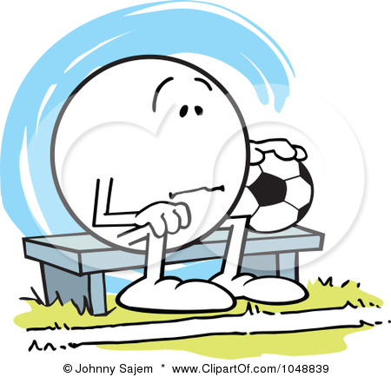

Does someone on your team look like this on game day because they forgot something?

The solution is a team equipment bag brought to every game.

Below is a list that was provided by one of the club's team parent equipment managers. He has over ten years experience keeping a team equipment bag and is known as a "Hero" by many of the players he has helped over the years. Items and quantities vary based on age of team and number of players. Place all the items in a rolling backpack and assign a parent to bring the team equipment bag to each game.

- First Aid Kit (include large plastic bandages for turf burns and "goalie knees", pre-wrap and tape as some trainers at tournaments now charge for these items)
- Something to treat Blisters
- Muscle cream (Ben Gay, etc)
- Extra Tape in white/royal blue (to hold elastic wrap or to hold up socks)
- Several elastic wraps
- Advil
- Ball pump
- Shoelaces (extra long for cleats)
- Hair bands/elastics
- (Contact) Saline Solution (for contacts or to clean wounds)
- Sunscreen
- Bug Spray
- Chap stick
- Clear Plastic trash bags (to place player's team backpacks in during rain, to sit on, to wear, to use as trash bag)
- Small sealing plastic bags (multitude of uses such as an ice pack, to hold player's jewelry, keep player passes dry in bad weather)
- Duct Tape (can be used to hold cleats together in an emergency)
- Extra uniform kit/extra uniform socks/Extra pair of shin guards (players are known to forget or lose these items come game time)
- Space blanket (has a reflective material on one side - to reflect the heat. Provides warmth on cold rainy days and keeps injured players warm).
- Baby Powder/talc (for those players that forget their compression shorts)
- One time use Ice Packs
- Stop watch (to time the games)
- Towels (for drying hands, benches and soccer balls)

Also a small cooler filled with ice in zip lock bags (for injuries). Small washcloths can also be kept in bags in the cooler and used on a player's neck in the heat.

